**Data Flow Diagram :**

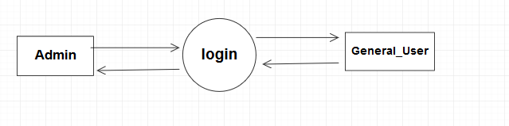

**Use case diagram :**

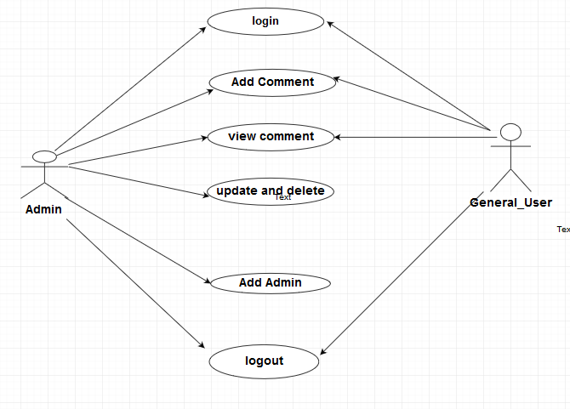

**Activity Diagram :**

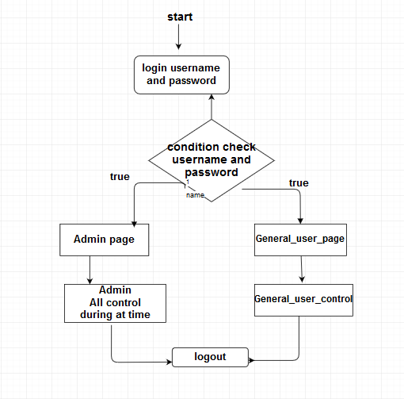

**ERD (ENTITY RELATIONSHIP DIAGRAM) :**

**Database relationship diagram :**

